Low Level Design (Login Module)

Project Code | Team6
Project Name | Media Composer and Artist Management System

Prepared/Modified by | Role | Date of Preparation
Raunak Agarwal | Senior Software Engineer | 13/11/2017
Reviewed by | Role | Date of Review
Vaishali Srivastava | Analyst | 14/11/2017
Approved by | Role | Date of Approval
Vishal Mali | Senior Analyst
Circulation List | raunak.agarwal@capgemini.com  shubham.ayush@capgemini.com  saptarshi.saha@capgemini.com  pratik.sahoo@capgemini.com  vaishali.srivastava@capgemini.com  vishal.mali@capgemini.com | Version Number of the template:1.0
Version Number | 1.3

Table of Contents

1. Description Of The Unit 3
2 References 4
3. Dependencies / Assumptions 5
4. Class Diagrams 6
5. Sequence Diagrams 7
6. Design Components 8
a. List Of UI Components 8
b. List Of Design Classes 9
7. Re-Usable Routines/Components 10
8. Messages 11
9. Configuration Files 12
10. Crud Matrix Table 13
11. Data Mapping Matrix 14
12. Action Flow Matrix 15
13. Stored Procedures 16
14. Program Specification / Pseudo Code 17
REVISION HISTORY OF THE WORK PRODUCT 19

Description Of The Unit

The login module allows the users of the application to login into the system using their valid credentials.

The userId and password entered by the user is validated from the database. If the entered credentials are valid then he/she is redirected to their respective pages based on their roles. Admin is redirected to Admin Page where options are provided to add or update a Product.
If the entered credentials are invalid then he/she is redirected to the login page and an appropriate error message is displayed.

2 References

Reference | Description
Repository reference | https://github.com/pratik77/plp
Class Diagram | /Project Documents/Design Documents/HLD/Class Diagrams
URS | /Project Documents/Requirements/Case Study/Media.doc
UTP | /Project Documents/Test Plan/UTP/Test Cases/Login Module/UTP_LoginModule.xls
DB Design | /Project Documents/Design Documents/HLD/DB Design/MediaComposerSystem_Group6_DBDESIGN.xls

Dependencies / Assumptions

Assumptions:
UserId and password of the user are in the database. The Admin valid credentials already exist in the database.

Class Diagrams

Class Diagram

Sequence Diagrams

Sequence Diagram
N/A

Design Components

List Of UI Components

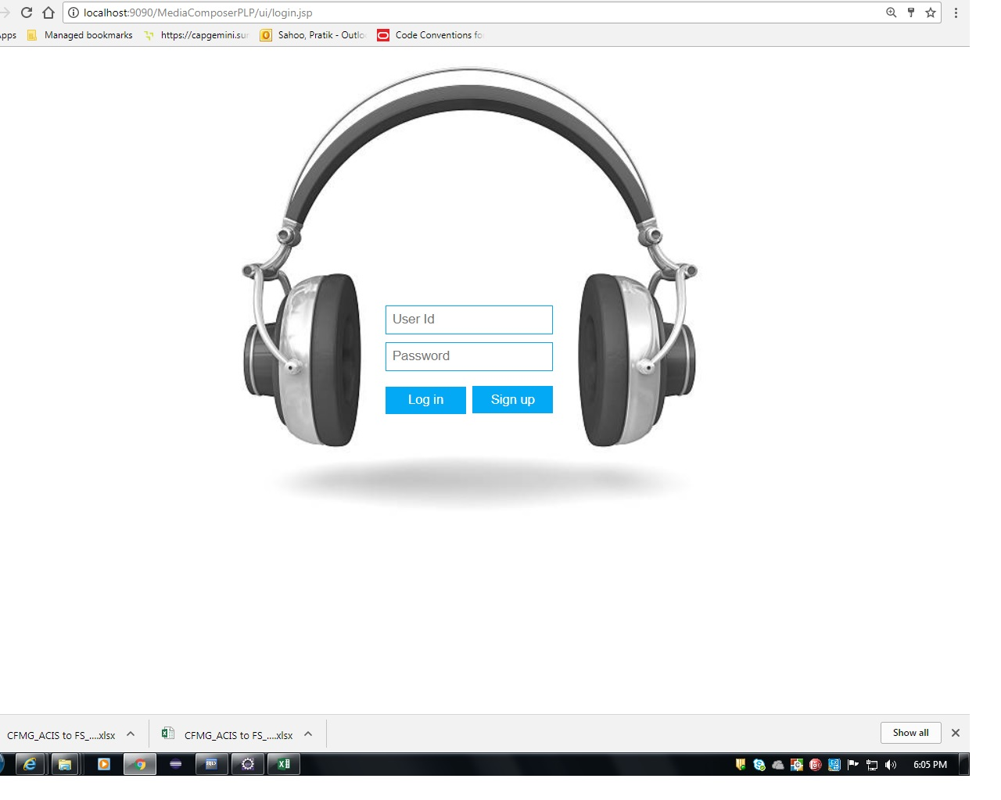

List Of Design Classes

Sr. No. | LLD Name | Class Name | Method Name | Method Description
1 | Login Module | Admin | Appropriate getters and setters methods | Getters retrieve the property values and setters set the property values
2 | Login Module | MediaController | checkLogin(@RequestParam("username") int username, RequestParam("password") String password,Model model) | Sets the model attribute.  Calls checkLogin() of MediaServiceImpl class, which in turn calls checkLogin() of MediaDAOImpl and then it redirects to appropriate Pages for the admin.
3 | Login Module | MediaServiceImpl | checkLogin(): Admin | Calls checkLogin () of MediaDAOImpl class and returns the result to controller.
4 | Login Module | MediaDAOImpl | checkLogin(): Admin | Validates userId and password as per the database and returns the result to MediaServiceImpl .

Re-Usable Routines/Components

Re-Usable Routines/Components

- CSS files
- Javascript files
- DataAccessException class
- Database properties files
- Logger properties files

Messages

#. | Type | Message Text
M1. | Error | Invalid User Name/ Password

Configuration Files

File Name | Path | Description
oracle.properties | /Development/Source | To configure database connection.
Web.xml | /Development/Source | To configure the bean properties.
Dispatcher-servlet.xml | /Development/Source | To configure the request mapping and view resolver.
logger.properties | /Development/Source | To configure the logger.
error.properties | /Development/Source | To configure error messages.
JPAContext.xml | /Development/Source | To configure the datasource, entity manager factory and transaction manager.

Crud Matrix Table
# | Table Name | Create | Read | Update | Delete
1 | User_Master | N | Y | N | N

Data Mapping Matrix

Sr. No. | Screen Label | Field Source | Field Type | Data Type | Max Length | Data Flow | Mandatory
1 | UserId | N/A | Label | N/A | N/A | UI | N/A
2 | userId | User.User_id | TextBox | Number | 6 | UI→D | Yes
3 | UserPassword | NA | Label | N/A | N/A | UI | N/A
4 | userPassword | User.Password | TextBox | Varchar2 | 20 | UI→D | Yes
5 | Login | N/A | Submit | N/A | N/A | UI | N/A
6 | Sign Up | N/A | Link | N/A | N/A | UI | N/A

Legend

UI (User Interface Only)
UI → D (User Interface to Database)
D → UI (Database to User Interface)

Action Flow Matrix
Sr. No. | Action | Description | Process
1 | On click of Login Button | Valid Admin gets logged | UserId and Password is validated from the database. If user is valid he/she is directed to the Menu Page.

Stored Procedures

# | Stored Procedure Name  (with Description) | Input/Out Parameters | Type | Size
1. | NA | NA | NA | NA

Program Specification / Pseudo Code

14. 1 <ACTION: ONPAGE_LOAD>

Pseudo Code:

- Client Side Scripting
None
- Server Side Scripting

BEGIN
Call checkLogin(@RequestParam("username") int username, @RequestParam("password") String password, Model model) in MediaController
class.
Navigates to Login Page.
END

14. 2 <ACTION: LOGIN_CLICK>

Pseudo Code:

- Client Side Scripting:

IF UserId isEmpty
Print Error Message M1
IF Password isEmpty
Print Error Message M1
IF invalid UserId
Print Error Message M1
IF invalid Password
Print Error Message M1
IF length of UserId > 6 characters
Print Error Message M1

- Server Side Scripting:
BEGIN
Call checkLogin(@RequestParam("username") int username, @RequestParam("password") String password, Model model) in MediaController class in Presentation Layer
BEGIN
Call checkLogin(int username, String password) in MediaServiceImpl class in Service Layer
BEGIN
Call checkLogin(int username, String password) in MediaDAOImpl class in Data Access Layer
BEGIN
Create query to search if the user exists or not
END
Return String to MediaServiceImpl
END
Return String to MediaController class
END
Navigate to Menu page
END
REVISION HISTORY OF THE WORK PRODUCT
# | Date | Version # | Section Changed | Details of changes made | Approved By
1 | 13/11/2017 | 1.0 | LLD prepared | N/A | Vishal Mali
2 | 05/11/2017 | 1.1 | Reusable components,  Pseudo code | Reusable components added.  The pseudo code is modified as per the specified flow. | Vishal Mali
3 | 08/11/2017 | 1.2 | Reusable components,  References,  Data Mapping Matrix. | Reusable Components added.  File name with relative path is added in the references section.  The name of text boxes(screen label is changed). | Vishal Mali
4 | 09/11/2017 | 1.3 | Configuration files,UI Components | Paths of the configuration files is updated and UI components(Screen Shots) added. | Vishal Mali

